Reducing IT Investment Risk:

Failure is an ongoing issue

IT investment is not without risk. Despite the excess of best practices available to help guide IT deployment projects, organizations continue to struggle to achieve anticipated benefits. One study indicates that over 40% of all IT projects fail to meet their business objectives (Kaplan & Harris-Salamone 2009), and another recent survey of 5,400 large scale IS implementation projects (projects exceeding $15 million) found that over 45 percent of all IT projects ran over budget while delivering 56 percent less value than predicted (Bloch et al. 2012). Such failures are not only frequent but are also quite costly; for example, a study of 134 European companies found the average cost of IT project failures to be $14 million, with examples of individual failures as high as $240 million (Rosen 2005).

A recent study by the Standish Group identified 7 key factors which contribute to IT project failure:

* Lack of Visibility into all Projects
* Poor Resource Management Resources
* Gaps & “Noise” in Communication and Information Scattering
* Poorly Defined Requirements (i.e., Poor Scope Definition)
* Poorly Defined or Unrealistic Timelines
* Inaccurate and Unrealistic Estimating
* Monitoring and Control

In response to these problems, companies are increasingly working toward detailed processes to help guide project to success. One of the mode popular models in this area is the SQLC:

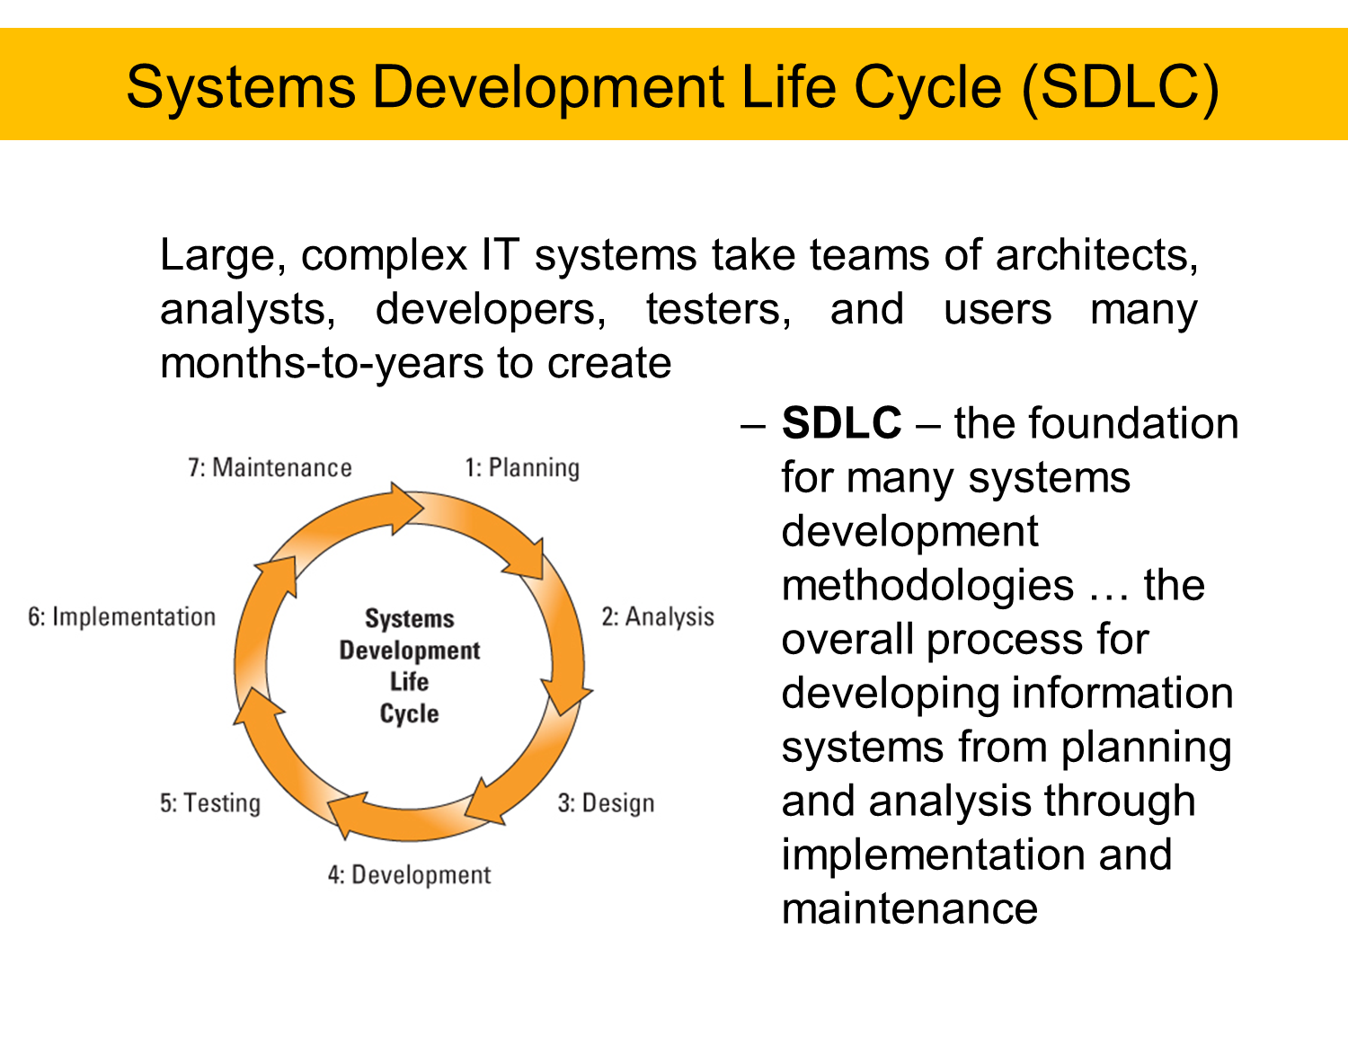

Figure 1: From MIS301 2017, Dr. Jon Beard

As MIS majors entering the market place, one of your key differentiators will be your ability to understand these issues and bring with you the skills and expertise that can assist business organizations to help reduce the risks of IT investments, and increase the returns achieved.

**Bibliography**

Bloch, M., Blumberg, S. & Laartz, J., 2012. Delivering large-scale IT projects on time, on budget, and on value. *McKinsey Quarterly*.

Kaplan, B. & Harris-Salamone, K., 2009. Health IT success and failure: recommendations from literature and an AMIA workshop. *Journal of the American Medical Informatics Association*, 16(3), pp.291–299.

Rosen, P., 2005. Acceptance and Rejection: Two Sides of the Same Coin, or Two Different Coins? *DIGIT 2005 Proceedings*, p.2.